Project Development Phase
Model Performance Test

Date | 10 February 2025
Team ID | LTVIP2025TMID38735
Project Name | Rice Type Detection System
Maximum Marks

Model Performance Testing:
Project team shall fill the following information in model performance testing template.
S.No. | Parameter | Values | Screenshot
 | Model Summary | CNN with 4 conv layers + 2Dense layers  Total Params:1.2M | 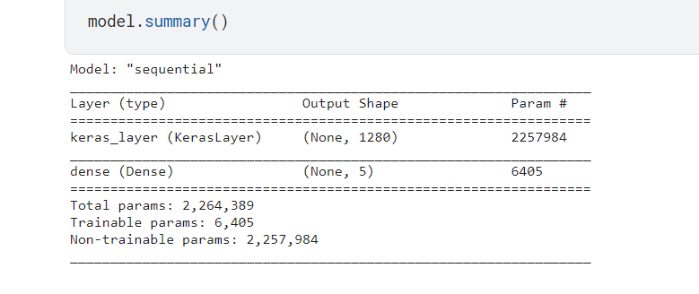
 | Accuracy | Training Accuracy :98%  Validation Accuracy :98% | 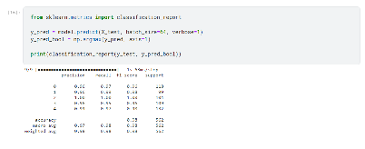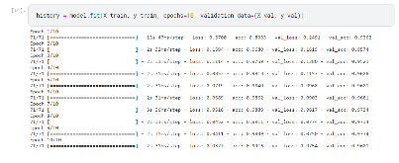
3. | Fine Tunning Result( if Done) | Validation Accuracy :96% | 